**Lab Assignment – 3**

**Name: Vaghela Shyam**

**Roll No.: 19**

**Class: B**

**Q.1 Write a program to insert element into the stack and display the element.**

**Code:**

/* Name:Vaghela Shyam

Class:B

Roll No.:19 */

#include<stdio.h>

#include<conio.h>

#define SIZE 4

int inp_array[SIZE],top = -1;

void push(){

int x;

if(top == SIZE - 1){

printf("\n overflow");

}

else{

printf("Enter the element to be added onto the stack:");

scanf("%d",&x);

top = top + 1;

inp_array[top] = x;

}

}

void show(){

int i;

if (top == -1)

{

printf("\nUnderflow");

}

else{

printf("\nElements present in the stack:\n");

for(i = 0; i<top+1; i++){

printf("%d\n",inp_array[i]);

}

}

}

void main(){

int i,op;

clrscr();

printf("Name:Vaghela Shyam\n Class:B\n Roll No.:19\n\n");

for(i=0;i<SIZE;i++){

printf("Enter the all elements[%d]:",i);

scanf("%d",&inp_array[i]);

top = top + 1;

}

while(1){

printf("\nFor Push Element Enter 1\n");

printf("For Showing elemnts Enter 2\n");

printf("For Exit enter 3\n");

printf("Select the operation to be performed:");

scanf("%d",&op);

switch(op){

case 1:

push();

break;

case 2:

show();

break;

case 3:

exit();

break;

default:

printf("Enter Valid value");

}

}

getch();

}

**Output:**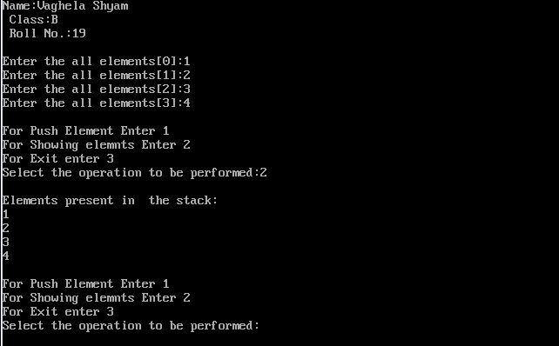

**2. Write a program to delete an element into the stack and display the element.**

**Code :**

/* Name:Vaghela Shyam

Class:B

Roll No.:19 */

#include<stdio.h>

#include<conio.h>

#define SIZE 4

int inp_array[SIZE],top = -1;

void pop(){

if(top == -1)

{

printf("\nUNderflow");

}

else{

printf("\nPopped element: %d\n",inp_array[top]);

top = top - 1;

}

}

void show(){

int i;

if (top == -1)

{

printf("\nUnderflow");

}

else{

printf("\nElements present in the stack:\n");

for(i = 0; i<top+1; i++){

printf("%d\n",inp_array[i]);

}

}

}

void main(){

int i,op;

clrscr();

printf("Name:Vaghela Shyam\n Class:B\n Roll No.:19\n\n");

for(i=0;i<SIZE;i++){

printf("Enter the all elements[%d]:",i);

scanf("%d",&inp_array[i]);

top = top + 1;

}

while(1){

printf("\nFor popping Elemnt enter 1\n");

printf("For Showing elemnts Enter 2\n");

printf("For Exit enter 3\n");

printf("Select the operation to be performed:");

scanf("%d",&op);

switch(op){

case 1:

pop();

break;

case 2:

show();

break;

case 3:

exit();

break;

default:

printf("Enter Valid value");

}

}

getch();

}

**Output:**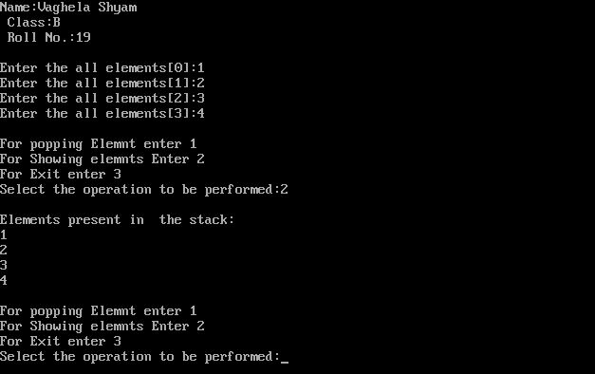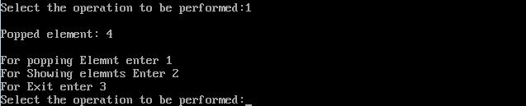

**3. Write a program to insert element into the queue and display the element.**

**Code :**

/* Name:Vaghela Shyam

Class:B

Roll No.:19 */

#include<conio.h>

#include<stdio.h>

#define SIZE 100

int arr[SIZE];

int rear=-1;

int front = -1;

void enqueue(){

int insert_item;

if(rear == SIZE - 1)

printf("Overflow!\n");

else{

if(front == -1)

front = 0;

printf("Element to be inserted in the queue:");

scanf("%d",&insert_item);

rear = rear+1;

arr[rear] = insert_item;

}

}

void show(){

int i;

if(front == -1)

printf("Empty Queue\n");

else{

printf("Queue:\n");

for(i=front; i<=rear; i++){

printf("%d",arr[i]);

printf("\n");

}

}

}

void main(){

int ch;

clrscr();

printf("Name:Vaghela Shyam\n Class:B\n Roll No.:19\n\n");

while(1)

{

printf("1.Enqueue operation\n");

printf("2.Display Queue\n");

printf("3.Exit\n");

printf("Enter your choice of operation:");

scanf("%d",&ch);

switch(ch){

case 1:

enqueue();

break;

case 2:

show();

break;

case 3:

exit(0);

break;

default:

printf("Enter valid number.");

}

}

getch();

}

**Output :**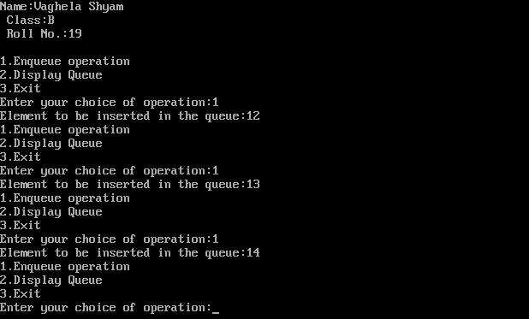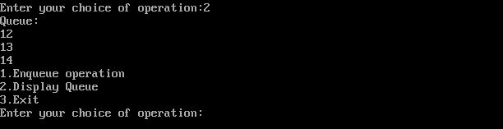

**4. Write a program to delete element into the queue and display the element.**

**Code :**

/* Name:Vaghela Shyam

Class:B

Roll No.:19 */

#include<conio.h>

#include<stdio.h>

#define SIZE 100

int arr[SIZE];

int rear=-1;

int front = -1;

void dequeue(){

if(front == -1 || front>rear){

printf("Underflow!\n");

}

else{

printf("Element deleted from the queue: %d\n",arr[front]);

front = front+1;

}

}

void show(){

int i;

if(front == -1)

printf("Empty Queue\n");

else{

printf("Queue:\n");

for(i=front; i<=rear; i++){

printf("%d",arr[i]);

printf("\n");

}

}

}

void main(){

int ch;

clrscr();

printf("Name:Vaghela Shyam\n Class:B\n Roll No.:19\n\n");

while(1)

{

printf("1.dequeue operation\n");

printf("2.Display Queue\n");

printf("3.Exit\n");

printf("Enter your choice of operation:");

scanf("%d",&ch);

switch(ch){

case 1:

dequeue();

break;

case 2:

show();

break;

case 3:

exit(0);

break;

default:

printf("Enter valid number.");

}

}

getch();

}

**Output :**

